PL-SQL Lab 1
VRINDA S NAIR
AM.SC.U4AIE23165

- Do all the questions discussed in the class
Q1.
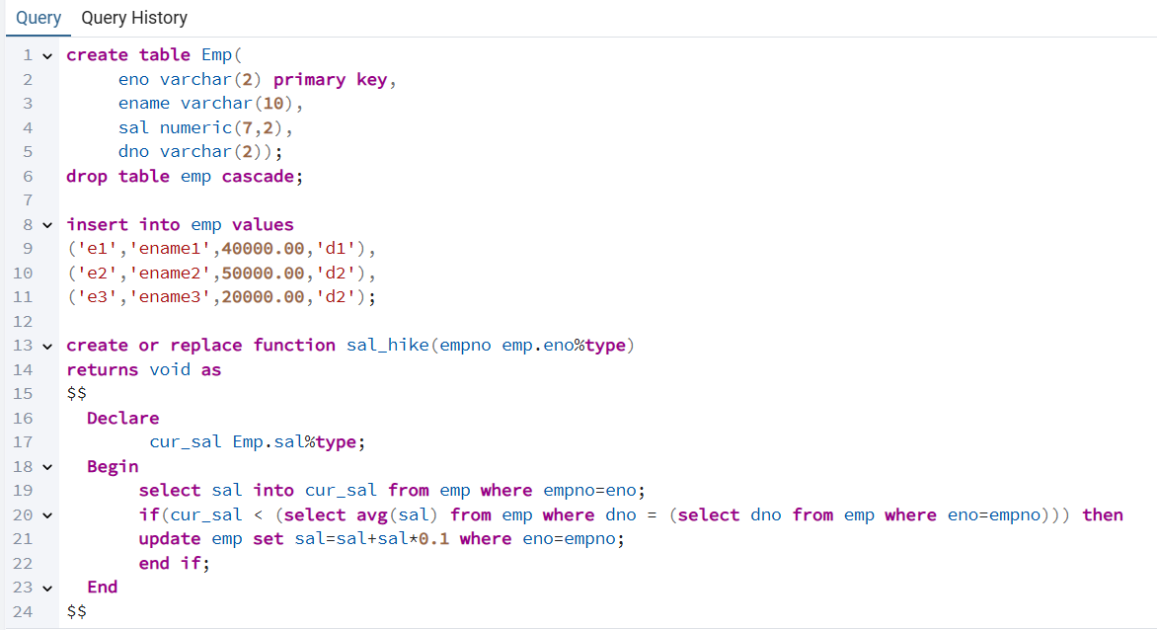
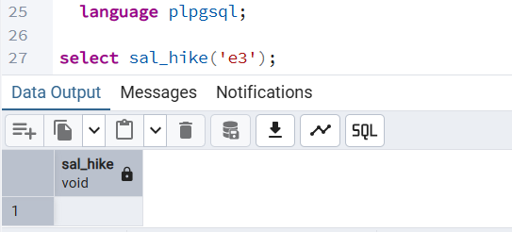

Q2.
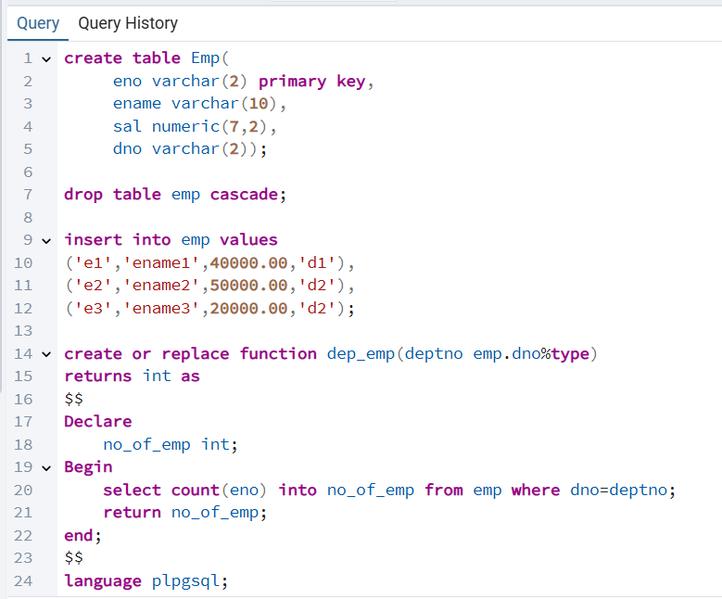
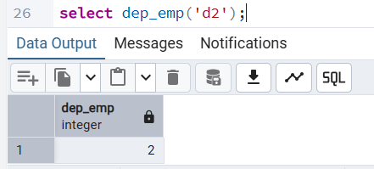
Q3.
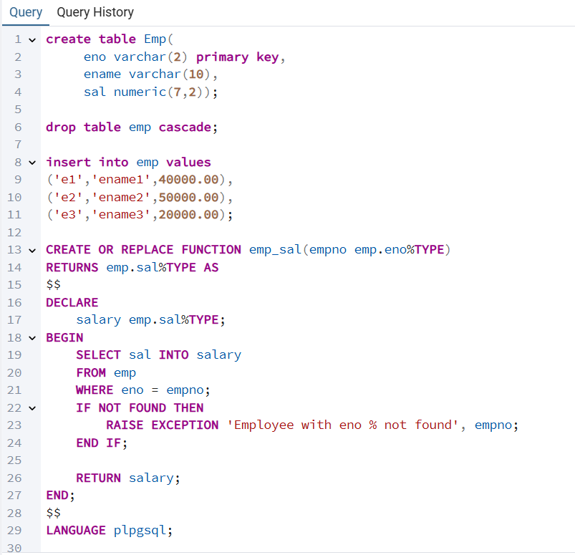
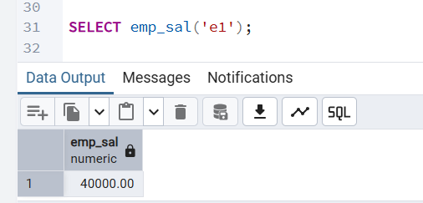
Q4.
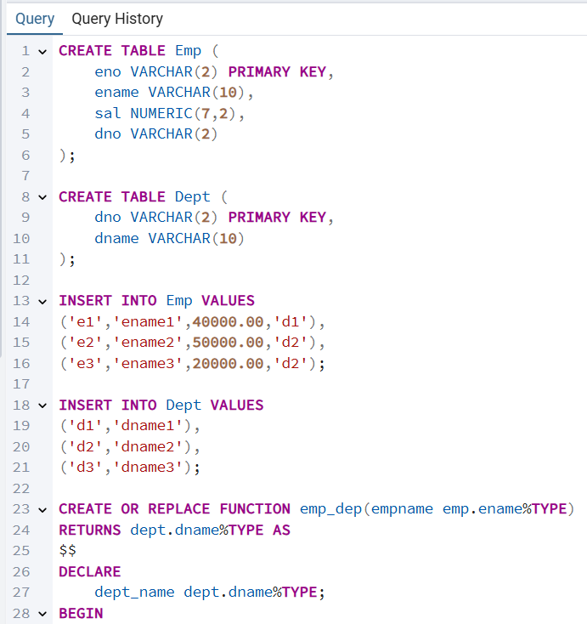
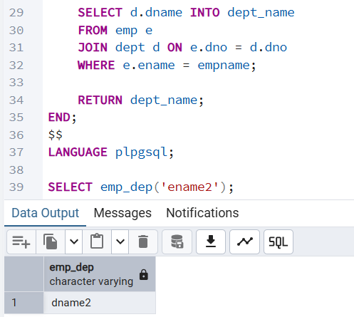

- Consider the following schema . Emp(eno, ename, sal)
EMP_PROJ(eno, pno, prjt_hrs).

  - Write a function ProjectLoad that returns the total project working hours for the given eno.
b) Write a PL/SQL code to update the salary of an employee if the employee earn less than the average salary.
New salary is current sal + difference between currrent sal and average salary
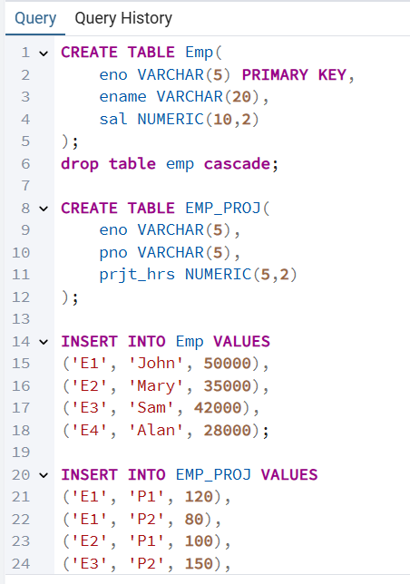.
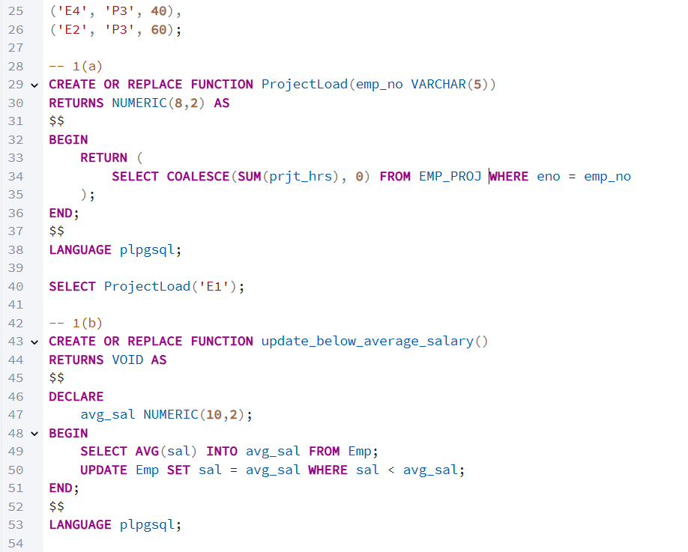
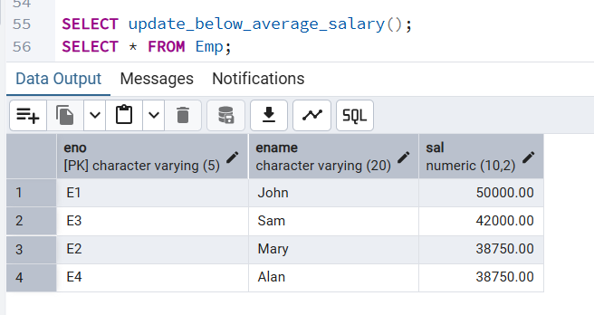
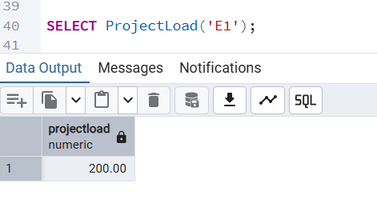
- Consider the following tables
Item(ino, iname, unit_price)
Transaction(tr_no,ino,qty)

Write a function to accept an item no from the user. If transaction has been made for less than 2 times for that item(check from transaction table), delete the item from the Item table.
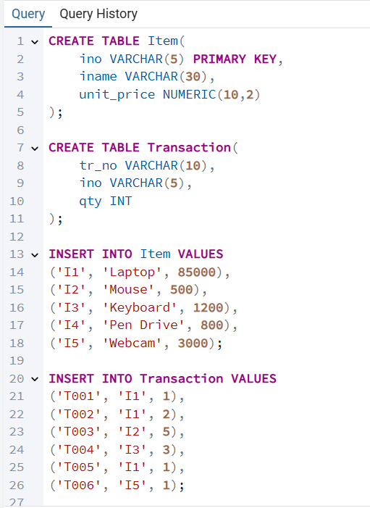
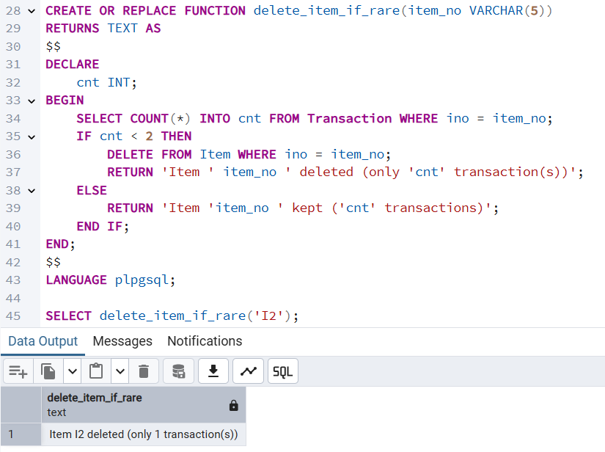
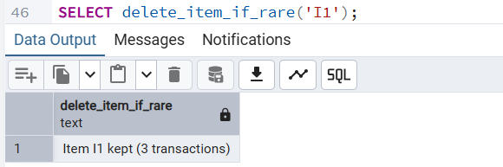
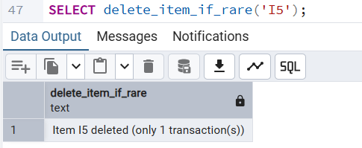
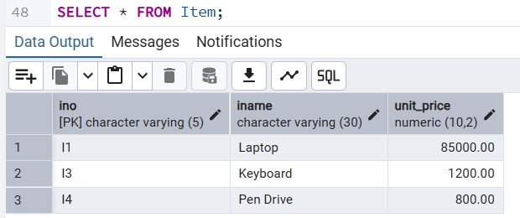
4. Consider a Bank database which includes the following tables.
ACCOUNTS(ac_no,br_no, cust_no,ac_type,bal)
BRANCHES(br_no, br_name, loc)
CUSTOMER(cno, cname, c_type)

  - Write a function that accepts a threshold value and a customer number . The program updates the c_type based on the threshold value. Ie. If balance> threshold then class A, else class B.
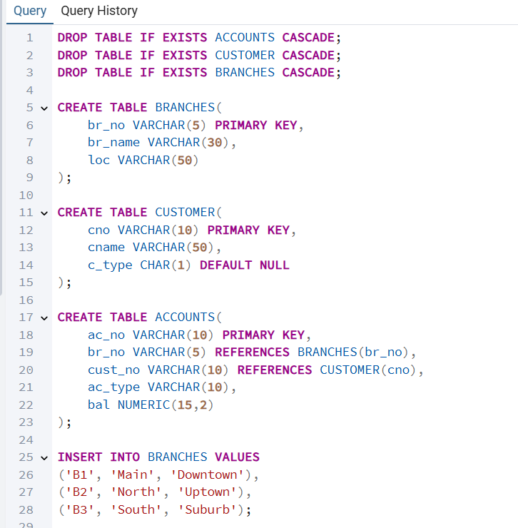
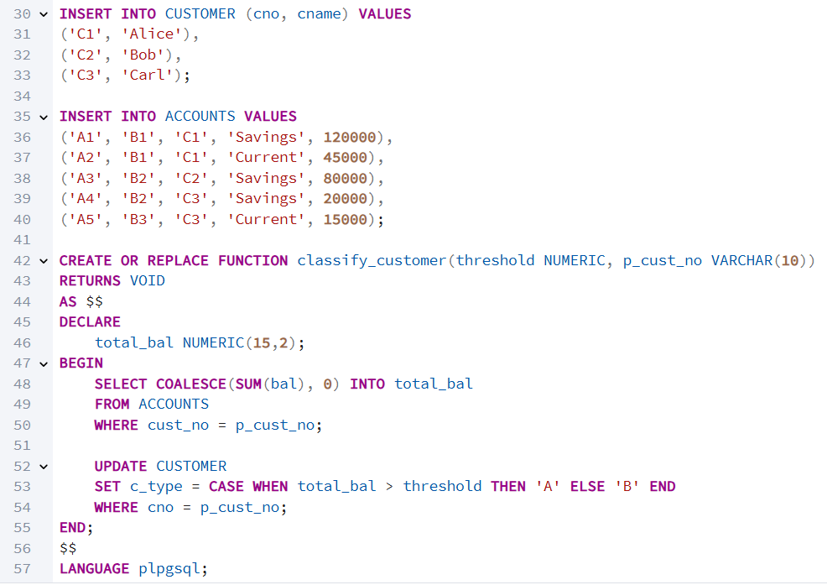
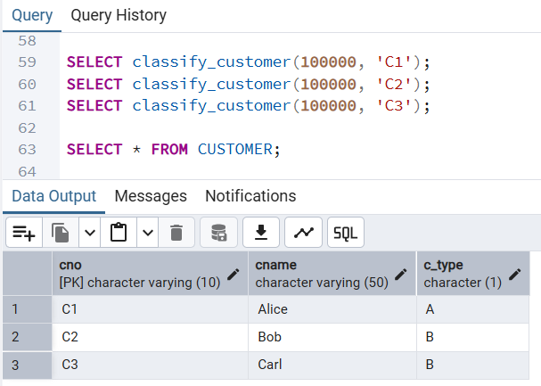
  - Write a function called CloseBranch that takes two arguments (the branch to be closed and the branch to take over the accounts) and transfers all accounts at the closing branch to the new branch and removes the closing branch.
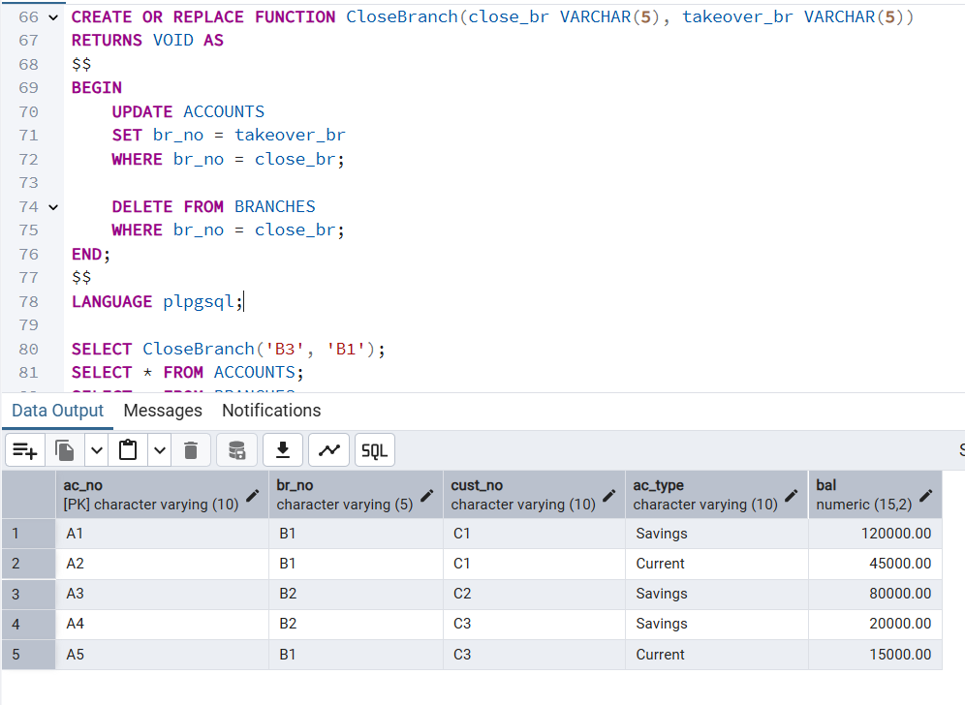
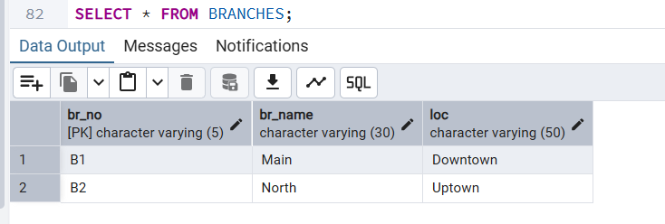
  - Write a function that implements a "safe" withdrawal operation, that only permits a withdraw if there sufficient funds in the account to cover it.
